# COMPUTER SCIENCE

**Name: Gaurang Soni**

**Class: 12 c**

**Academic year: 2021-2022**

## TOPIC OF THE PROJECT

## Stock Maintenance

2021-22

## FUNCTIONS AND

MODULES

**MODULES**

#### import mysql.connecter:

By importing this package, we are able to establish the connection between SQL and Python.

# FUNCTIONS

#### connect():

This function establishes connection between Python and MySQL.

#### cursor():

It is a special control structure that facilitates the row-by-row processing of records in the result set.

The syntax is:

<cursor object>=<connection object>.cursor()

#### execute():

This function is use to execute the sql query and retrieve records using python.

The syntax is:

<cursor object>.execute(<sql query string>)

#### fetchall():

This function will return all the rows from the result set in the form of a tuple containing the records.

#### commit():

This function provides changes in the database physically.

FLOW OF THE

PROJECT

The project is based on SMALL BUSINESS The project consists of 6 modules :

#### CREATE TABLE

1. **SHOW TABLE**
2. **INSERT RECORD**
3. **SHOW RECORD**
4. **DELETE RECORD**
5. **MODIFY**
6. **EXIT**

#### CREATE DATABASE:

In this option, the management can create a database in which the following details can be entered in the table such as storage item, item name, location, product id etc.

as assets, liabilities, profits, expenditures etc.

#### INSERT RECORD:

#### In this option, the INSERT command creates a new row in the table to store data. The management can insert a record in the database in the Stock table.

III.show table

Being able to quickly organize our data into a more readable format, such as when data wrangling, can be extremely helpful in order to analyze the data and plan the next steps. Python offers the ability to easily turn certain tabular data types into nicely formatted plain-text tables

IV.show record

In a database, a record (sometimes called row) is a group of fields within a table that are relevant to a specific entity. In mysql, you view these selected records.

V.Delete record

The DELETE query is used to delete the existing records from a table. You can use the WHERE clause with a DELETE query to delete the selected rows, otherwise all the records would be deleted.

VI.Modify

MySQL provides the ALTER function that helps us incorporate the changes to the already existing database design. The alter command is used to modify an existing database, table, view or other database.

VII. Exit

The exit() function is used to exit the program.

SOURCE CODE

import mysql.connector as s

myconn=s.connect(host='localhost', user='root', passwd='gaurang', database='stockmain_system')

def createtables():

cur=myconn.cursor()

cur.execute("create table productinfo(pid int,pname char(10),description char(15))")

cur.execute("create table locationinfo(lname char(20),city char(10))")

cur.execute("create table priceinfo(price int)")

if myconn.is_connected():

print("Tables creation success")

def menu():

cur=myconn.cursor()

ch='y'

while ch=='y' or ch=='Y':

print("1.createtables")

print("2.showtables")

print("3.insertion")

print("4.product details")

print("5.location details")

print("6.price details")

print("7.modification")

print("8.deletion")

print("9.exit")

c=int(input("enter choice your choice"))

if(c==1):

createtables()

elif (c==2):

showtables()

elif (c==3):

insertion()

elif (c==4):

productdetails()

elif (c==5):

locationdetails()

elif (c==6):

pricedetails()

elif (c==7):

modification()

elif (c==8):

deletion()

elif (c==9):

break

ch=input("enter your choice 'y' for yes and 'n' for no to continue")

def showtables():

cur=myconn.cursor()

cur.execute("show tables")

print ("These are the tables:")

for i in cur:

print(i)

def insertion():

cur=myconn.cursor()

ch='y'

while True:

if(ch=='y' or ch=='Y'):

print("*****Insert any changes?******")

print("1.insproduct")

print("2.inslocation")

print("3.insprice")

print("4.exit")

c=int(input("enter your choice"))

if(c==1):

insproduct()

elif(c==2):

inslocation()

elif(c==3):

insprice()

elif(c==4):

menu()

ch=input("enter your choice 'y' for yes and 'n' for no")

myconn.commit()

def insproduct():

cur=myconn.cursor()

c='y'

while True:

if (c=='y' or c=='Y'):

pid=int(input("enter product id"))

pname=input("enter product name")

description=input("enter product description")

cur.execute("insert into productinfo values({},'{}','{}')".format(pid,pname,description))

myconn.commit()

c=input("enter y for yes and n for no")

else:

insertion()

def inslocation():

cur=myconn.cursor()

c='y'

while True:

if (c=='y' or c=='Y'):

lname=input("enter location name")

city=input("enter city name")

cur.execute("insert into locationinfo values('{}','{}')".format(lname,city))

myconn.commit()

c=input("enter y for yes and n for no")

else:

insertion()

def insprice():

cur=myconn.cursor()

c='y'

while True:

if (c=='y' or c=='Y'):

price=input("enter product price")

cur.execute("insert into priceinfo values({})".format(price))

myconn.commit()

c=input("enter y for yes and n for no")

else:

insertion()

def insertion():

cur=myconn.cursor()

ch='y'

while True:

if(ch=='y' or ch=='Y'):

print("*****Insert any changes?******")

print("1.insproduct")

print("2.inslocation")

print("3.insprice")

print("4.exit")

c=int(input("enter your choice"))

if(c==1):

insproduct()

elif(c==2):

inslocation()

elif(c==3):

insprice()

elif(c==4):

menu()

ch=input("enter your choice 'y' for yes and 'n' for no")

def productdetails():

cur=myconn.cursor()

cur.execute("select * from productinfo")

data=cur.fetchall()

print ("Product Details:")

for i in data:

print(i[0],i[1],i[2])

def locationdetails():

cur=myconn.cursor()

cur.execute("select * from locationinfo")

data=cur.fetchall()

print("Location details:")

for i in data:

print(i[0],i[1])

def pricedetails():

cur=myconn.cursor()

cur.execute("select * from priceinfo")

data=cur.fetchall()

print("Product Price details:")

for i in data:

print(i[0])

def modification():

cur=myconn.cursor()

ch='y'

while ch=='y' or ch=='Y':

print("*****Any modifications?******")

print("1.product modification")

print("2.location modification")

print("3.price modification")

print("4.exit")

c=int(input("enter your choice"))

if(c==1):

modproduct()

elif(c==2):

modlocation()

elif(c==3):

modprice()

elif(c==4):

menu()

ch=input("enter your choice 'y' for yes and 'n' for no")

def modproduct():

cur=myconn.cursor()

pid=int(input("enter product id for modification"))

pname=input("enter new name")

description=input("enter new description")

cur.execute("update productinfo set pid='{}',pname='{}',description='{}'".format(pid,pname,description))

myconn.commit()

cur.execute("select * from productinfo")

data=cur.fetchall()

for i in data:

print(i[0],i[1],i[2])

def modlocation():

cur=myconn.cursor()

lname=input("enter new location name")

city=input("enter new city name")

cur.execute("update locationinfo set lname='{}',city ='{}'".format(lname,city))

myconn.commit()

cur.execute("select * from locationinfo")

data=cur.fetchall()

for i in data:

print(i[0],i[1])

def modprice():

cur=myconn.cursor()

price=input("enter new price")

cur.execute("update priceinfo set price='{}'".format(price))

myconn.commit()

cur.execute("select * from priceinfo")

data=cur.fetchall()

for i in data:

print(i[0])

def deletion():

cur=myconn.cursor()

ch='y'

while ch=='y' or ch=='Y':

print("*****Any Deletions?******")

print("1.product deletion")

print("2.location deletion")

print("3.price deletion")

print("4.exit")

c=int(input("enter your choice"))

if(c==1):

delproduct()

elif(c==2):

dellocation()

elif(c==3):

delprice()

elif(c==4):

menu()

ch=input("enter your choice 'y' for yes and 'n' for no")

def delproduct():

cur=myconn.cursor()

pid=int(input("enter product id for deletion"))

cur.execute("delete from productinfo where pid={}".format(pid))

myconn.commit()

cur.execute("select * from productinfo")

data=cur.fetchall()

for i in data:

print(i[0])

def dellocation():

cur=myconn.cursor()

lname=input("enter location name for deletion")

cur.execute("delete from locationinfo where lname='{}'".format(lname))

myconn.commit()

cur.execute("select * from locationinfo")

data=cur.fetchall()

for i in data:

print(i[0])

def delprice():

cur=myconn.cursor()

price=int(input("enter price for deletion"))

cur.execute("delete from priceinfo where price={}".format(price))

myconn.commit()

cur.execute("select * from priceinfo")

data=cur.fetchall()

for i in data:

print(i[0])

menu()

OUTPUT

For number “1”

1.createtables

2.showtables

3.insertion

4.product details

5.location details

6.price details

7.modification

8.deletion

9.exit

enter choice your choice1

Tables creation success

For number “2”

1.createtables

2.showtables

3.insertion

4.product details

5.location details

6.price details

7.modification

8.deletion

9.exit

enter choice your choice2

These are the tables:

('locationinfo',)

('priceinfo',)

('product',)

('productinfo',)

enter your choice 'y' for yes and 'n' for no to continue

For number “3”

1.createtables

2.showtables

3.insertion

4.product details

5.location details

6.price details

7.modification

8.deletion

9.exit

enter choice your choice3

*****Insert any changes?******

1.insproduct

2.inslocation

3.insprice

4.exit

enter your choice1

enter product id13

enter product namescarf

enter product descriptionscarf is red

enter y for yes and n for non

*****Insert any changes?******

1.insproduct

2.inslocation

3.insprice

4.exit

enter your choice2

enter location nametailor

enter city namedelhi

enter y for yes and n for non

*****Insert any changes?******

1.insproduct

2.inslocation

3.insprice

4.exit

enter your choice300

enter your choice 'y' for yes and 'n' for no

For number “4”

1.createtables

2.showtables

3.insertion

4.product details

5.location details

6.price details

7.modification

8.deletion

9.exit

enter choice your choice4

Product Details:

13 scarf scarf is red

13 scarf scarf is red

13 scarf scarf is red

enter your choice 'y' for yes and 'n' for no to continue

For number “5”

1.createtables

2.showtables

3.insertion

4.product details

5.location details

6.price details

7.modification

8.deletion

9.exit

enter choice your choice5

Location details:

tailor delhi

enter your choice 'y' for yes and 'n' for no to continue

For number “6”

1.createtables

2.showtables

3.insertion

4.product details

5.location details

6.price details

7.modification

8.deletion

9.exit

enter choice your choice6

Product Price details:

300

enter your choice 'y' for yes and 'n' for no to continue

For number “7”

1.createtables

2.showtables

3.insertion

4.product details

5.location details

6.price details

7.modification

8.deletion

9.exit

enter choice your choice7

*****Any modifications?******

1.product modification

2.location modification

3.price modification

4.exit

enter your choice1

enter product id for modification13

enter new namescarftv

enter new descriptioncolour is redtv

13 scarftv colour is redtv

13 scarftv colour is redtv

13 scarftv colour is redtv

enter your choice 'y' for yes and 'n' for noy

*****Any modifications?******

1.product modification

2.location modification

3.price modification

4.exit

enter your choice2

enter new location nametailortv

enter new city namevizag

tailortv vizag

enter your choice 'y' for yes and 'n' for noy

*****Any modifications?******

1.product modification

2.location modification

3.price modification

4.exit

enter your choice3

enter new price1300

1300

enter your choice 'y' for yes and 'n' for no

For number “8”

1.createtables

2.showtables

3.insertion

4.product details

5.location details

6.price details

7.modification

8.deletion

9.exit

enter choice your choice8

*****Any Deletions?******

1.product deletion

2.location deletion

3.price deletion

4.exit

enter your choice1

enter product id for deletion13

enter your choice 'y' for yes and 'n' for noy

*****Any Deletions?******

1.product deletion

2.location deletion

3.price deletion

4.exit

enter your choice2

enter location name for deletiontailortv

enter your choice 'y' for yes and 'n' for noy

*****Any Deletions?******

1.product deletion

2.location deletion

3.price deletion

4.exit

enter your choice3

enter price for deletion1300

enter your choice 'y' for yes and 'n' for no

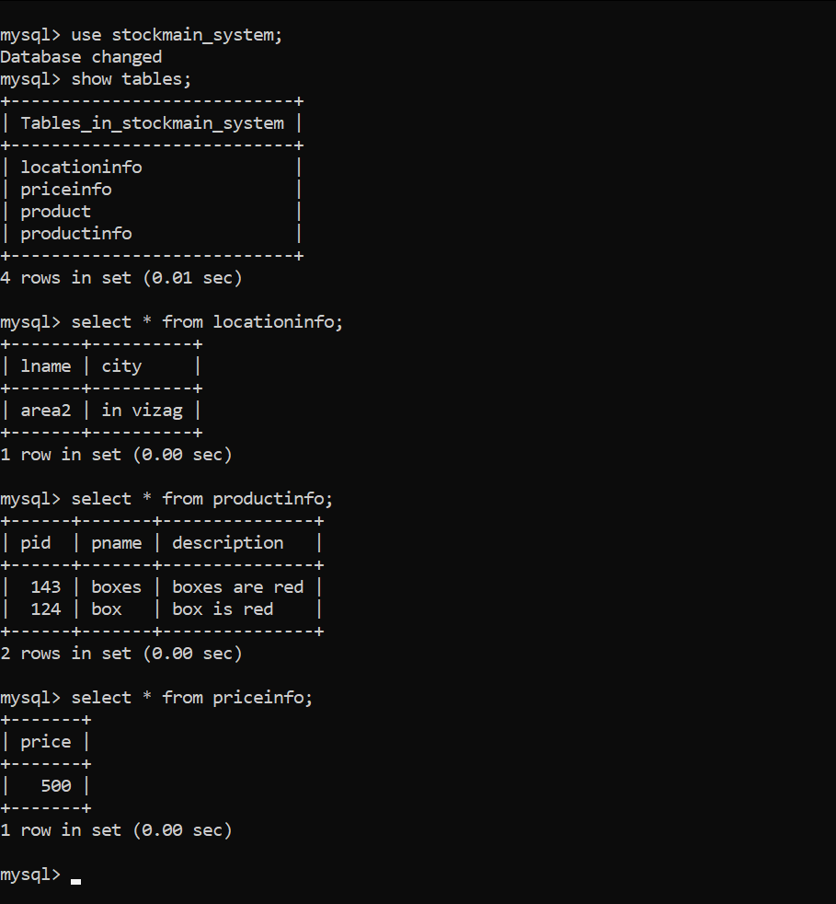**MySQL Output**